NLnet Virtual Distro Dispatcher Project
Milestone 2

15-09-2009

Work done

WP1 (from 01-08-2009 to 15-09-2009)
We encountered problems with the new architecture, so we needed to change it and start again. This slowed us down a bit, but at the end we succeded in carrying it through. We also implemented the high availability clustering solution within the new architecture.
An interesting aspect of the new architecture is that the GUI should now be easier to implement.
We then worked on the new web site and introduced web tools useful for the community building process. Details in the following.

Deliverables

Deliverables for the WP2 are:
- High availability clustering is working;
- Web site and tools are ready;
- Documentation.

They are presented in the following.

High availability clustering is working

We had to face unexpected problems that arised with the new architecture. Putting VDD server itself on a virtual machine made it impossible (or maybe hardly possible) to determine what and how many distros are available at a particular time. Moreover, using Xnest in the new environment, provoked malfunctionings that we were not able to debug. We finally discovered that using Xephyr, instead of Xnest, solves such problems and provides features (such as fullscreen) that can be quite useful for the development of VDD. Hence, we put the VDD server back on the Xen host, we tried out Xephyr, and everything was fine. We then designed and implemented a new architecture, depicted in Figure 1.

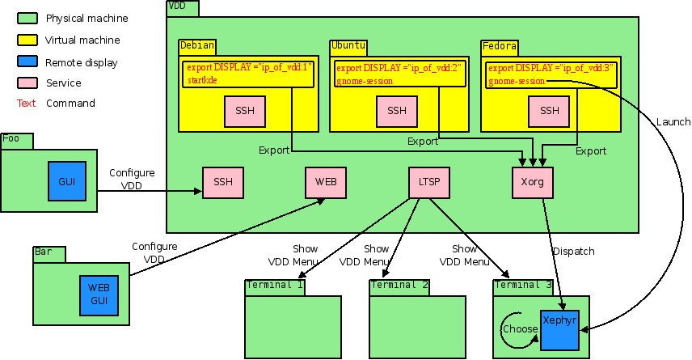

Figure 1

VDD server contains the virtual machines with the distros to be dispatched. In the example of Figure 1, three GNU/Linux distros are represented, Debian, Ubuntu and Fedora, each of which accessible via ssh from the outside. VDD server hosts the central Xorg system as well. The distros esport their display on such system. The terminals (thin clients) connects to the VDD server and show the VDD menu via LTSP (running on the server). Such menu will be developed for the next deliverables. It is intended to show a simple graphical menu where user can select the operating system to use and its features. Central Xorg system is in charge of dispatching distros. The user of the terminal chooses a distro and Xephyr is run to display it. By launchig the desktop environment from within the virtual machine, dispatching takes place and the user is able to use the distro he or she selected.
It will be also possible to configure VDD using a GUI, that will be developed for the next deliverables. This can be done from any machine, including terminals or (more probably) other machines (foo and bar in Figure 1).

All the system is now running on a cluster of two identical machines. A fail over system has been implemented, in order to achieve high availability. Such system is composed of three building blocks: DRBD, Heartbeat and Live migration.
DRBD mirrors a whole block device through the network. This guarantees the data of the two servers are constantly syncronized.
Heartbeat is a daemon that provides cluster infrastructure (communication and membership) services to its members (in our case, the members are two, but they can scale to several ones). This allows members to know about the presence (or disappearance) of peer processes on other machines in the cluster and to easily exchange messages with them.
Live migration is the movement of a virtual machine from one physical host to another while continuously powered-up. It takes place without any noticeable effect from the point of view of the end user.

We simulated various failures in the system and verified tha VDD users can continue to use the distro without noticing anything strange. Technical details on the implementation can be found in the documentation.

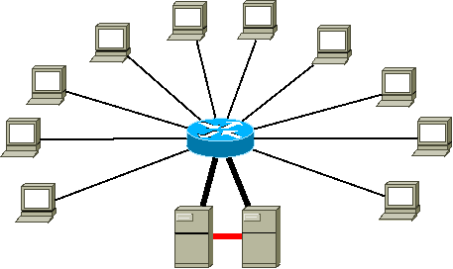

Figure 2

For implementing this high availability clustering solution, the 2 servers were equipped with a supplementary gigabit network card (red thick line in Figure 2). Such card connects the 2 servers directly, on a separate and dedicated network. This way they can syncronize themselves directly and very fast.

Web site and tools are ready

Work has been done on the following subjects:

a) Hosting
b) Web site graphics
c) Sections and contents
d) Community tools

a) The web site has been moved to a new (better) hosting system. Unlike before, it is now possible to install whatever tool we may need for the community (mailing lists, CVS, wiki, tracker and so on).

b) Joomla has been used to develop the web site. A new layout has been implemented. The new template is very simple, straightforward and serious. We got inspired, in particular, by the following two websites:
http://www.slackware.com/
http://www.busybox.net/
The restyling allows us to maintain a wide space for contents and the lateral column on the right, that, after the menu(s), ends up on cronological boxes (changelog, last updates from blogs...).

c) We planned site sections and contents (and community tools, as well) trying to focus on what communicate, to whom and how. The site (in english, of course) talks mostly to “smanettoni”, coders, academics and, in general, to people and groups operating in the world of Free Software. It offers informations on the project status, documentation about software, including howtos and links. We reorganized the old contents in order to make them more homogeneous and coherent with the target.

d) We activated a non-technical monthly newsletter. A technical changelog tool is used to keep track of what is done. We are going to publish news related to the project. There is a section dedicated to howtos and another to configurations. Should the community become populated enough (as we hope), we will start the forum, a wiki for the user FAQs and of course a repository for downloading and testing new versions. Registered users will have a centralised "todo list" in order to have the full picture of the development process on the web.

Now that we launched the web site, we are going to advertise the project in other communities using blogs, magazines, mailing lists, etc.
In the following, the web site structure.

MAIN MENU

About VDD
* What is VDD {static content}
* Architecture {static content}
* Screenshots {static content + gallery}
* License {static content}
* Download {static content > repository in future}

Documentation
* FAQ {core content > faq-module in future}
* How-tos {static content}
* Configurations {static content}
* Links {core-link}
* Invited talks and Conferences {static content > blog category in future}
* Publications {static content > blog category in future}

Development {externel wrapping}

nlnet project
* About nlnet {static content}
* Work plan {static content}
* Deliverables {static content}

Research {static content}

UPPER BAR

Home
About us {static content}
Newsletter {communicator-module}
Forum {kuena-module}
News {section/category blog in home}
Contact {core-contact}
Site map {x-map-module}
Search {core-module-search}

LOWER BAR

Credits {static content}
Sponsor {static content}
Copyright {static content}
Reserved area (developer only)

Documentation

Documentation of the project is now online, in order to provide how-tos to the community. It has got a more technical tone and is intended to grow and improve with the project.

